**Ghani, Yusof (1950-)**

Yusof Ghani a Malaysian artist who was significantly influenced by American Abstract Expressionism. Yusof Ghani's first solo exhibition in 1984 was held at Anton Gallery in Washington, DC where he showed his *Protest* series. However, this series failed to fit in with the work of other Malaysian artists who were at that time intent on developing a national identity for Malaysian art. Rather than acquiescing to the same theme, Yusof pursued his interest in ‘cultural dance,’ which he had explored in his MA thesis, eventually expanding it into the fundamental theme of his *Siri Tari* (Dance Series) (1984 – 1992). Yusof Ghani’s works possess an astonishing fluidity that captures the exhilaration and tension of his subject matter. Heavily influenced by Jackson Pollock and Willem de Kooning, Yusof Ghani’s works are intense, powerful and are usually noted for their spontaneous and ferocious brushstrokes. His works consist of abstract (or semi-abstract) forms and imageries, emphasizing formalistic experimentation in his use of colours, emphasis on the simplification of forms and expressive qualities of his lines.

Born in 1950 in Johor, Yusof was involved in graphic design between 1969 and 1979, working as an illustrator for a publishing firm. During this period, he also taught technical drawing and worked as a graphic artist at TV Malaysia. In 1979 he received a government grant and moved to the United States to continue his studies at George Mason University in Virginia where received his Bachelor in Fine Art majoring in Graphic Art. He then continued his Master of Fine Art in Washington DC at the Catholic University of America.

Yusof Ghani’s *Tari* Series, emphasises the action or movement of his subjects through the bewildering and aggressive quality of his lines. Inspired by the American Abstract Expressionists, this series also formed part of his commentary on local performance art and culture. By doing so, he superimposed, stylized and abstracted various intertwining dancing figures by exploring various lines and movement through his abstract composition.

Topeng (Mask) (1992) on the other hand was spurred by Yusof’s visit to Sarawak where he was captivated by the mask rituals of ethnic Kenyah and Kayan. From that point onwards he went on to produce other significant series, namely *Wayang*, *Hijau* (1998-2002), *Segerak* (2003-2006), and most recently, *Biring* (2007) and *Wajah* (2009). In a departure from his last series *Segerak* (2003-2006), which focused on the human form, *Biring* (2007) is the artist’s interpretation of a cockfight, symbolizing the heroism and strife between mankind using bold, expressive brush strokes and a myriad of colours.

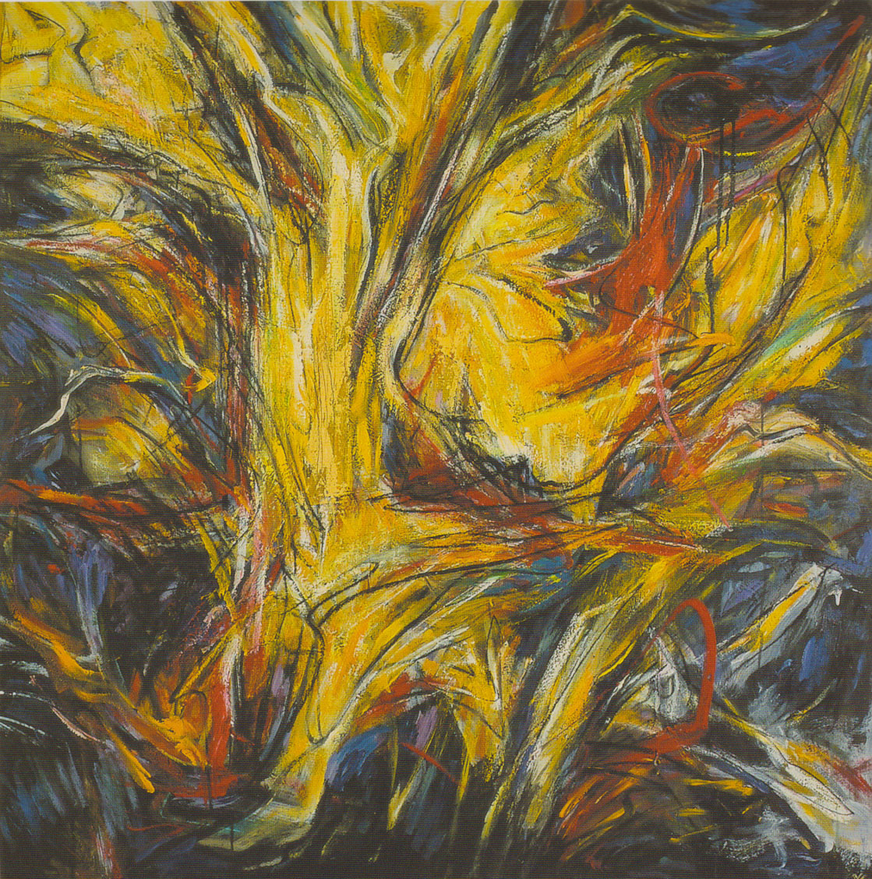

Rimba Terjun (2000), 122 x 122 cm, Oil on canvas.

(Image taken from *Yusof Ghani: Hijau 1998-2002*. Kuala Lumpur: Petronas, 2002. Permissions to be obtained.)

**References and further reading**

---- (1989) *Yusof Ghani*. Kuala Lumpur: GaleriCitra.

---- (1996) *Yusof Ghani: Siri Tari -- Topeng*. Kuala Lumpur: Rusli Hashim Fine Arts.

---- (2002) *Yusof Ghani: Hijau 1998-2002*. Kuala Lumpur: Petronas.

---- (2007) *Biring: Yusof Ghani*. Kuala Lumpur: Wei-Ling Gallery, 2007.

Mahmood, Muliyadi. (2004) *Segerak: Yusof Ghani*. Kuala Lumpur: Utusan Publication & Distributor.